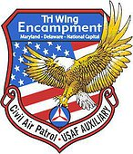
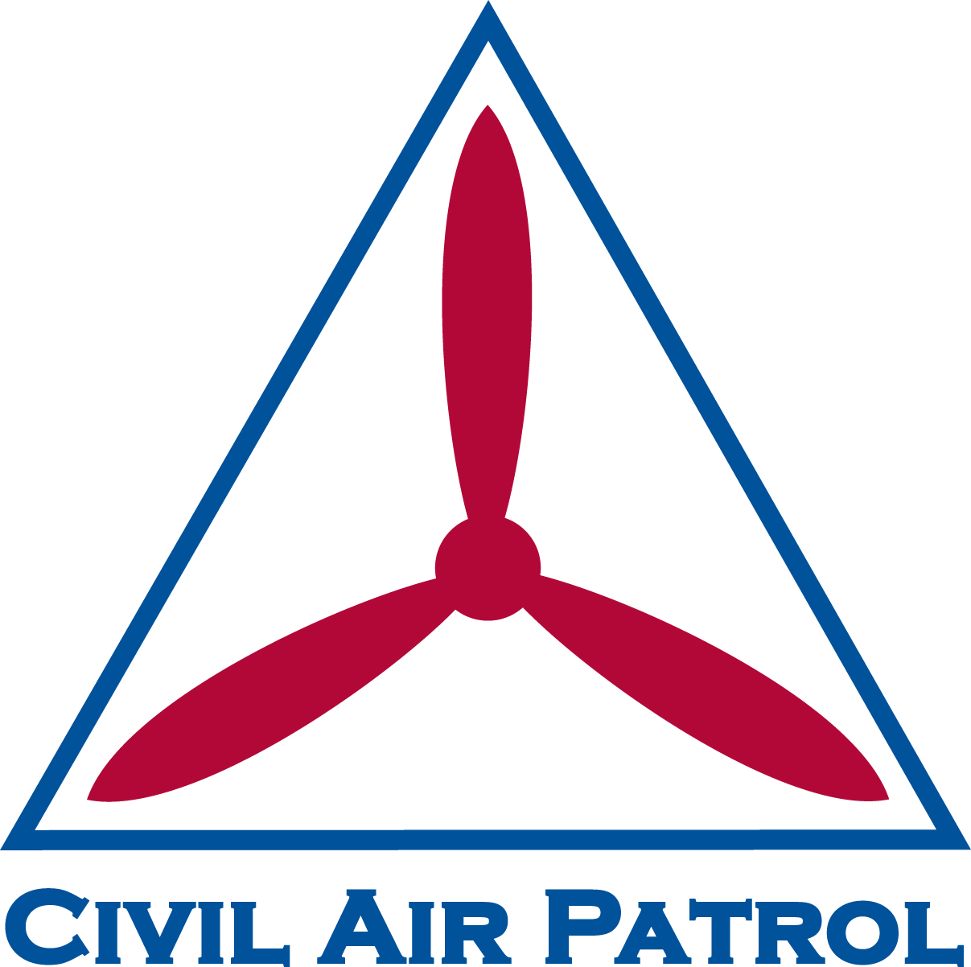
TRI-WING ENCAMPMENT
HOSTED BY MARYLAND WING
CIVIL AIR PATROL

UNITED STATES AIR FORCE AUXILIARY
3085 Hernwood Road
Woodstock, MD 21136

23 Oct 19
MEMORANDUM FOR NATIONAL CAPITAL WING
DELAWARE WING
MARYLAND WING

FROM: MDWG A7C

SUBJECT: Tri-Wing Encampment Senior Executive Cadre (SEC) Application Requirements

1. This letter is intended to inform interested members of the requirements to apply for the following positions at the 2020 Tri-Wing Encampment: Encampment Commander, Deputy Commander for Support, Curriculum and Plans Officer, Commandant of Cadets, and Chief Training Officer. Additional details on these positions may be found by referencing the Job Descriptions and the Tri-Wing Organizational Chart. Applicants must complete all requirements to be considered for a position. Applicants can apply for more than one position on SEC and senior cadre. Please include details on all potential positions in a single application, listed in order of preference. Please see below for details on application requirements.

- Civil Air Patrol Resume. Please include a professionally formatted resume. All relevant information including previous duty positions, activity participation, awards, ratings, and completed courses should be included. Consult AFH 33-337 as needed for examples of proper formatting.

- Letter of Intent. The letter of intent should detail which position(s) in which an applicant has interest. The letter of intent should be written per CAPR 10-1.

- References or Recommendation Letter. Applicants must include a minimum of two Civil Air Patrol Members who can be contacted as references OR a letter of recommendation. If submitting references, applicants must include the reference’s name, affiliation, e-mail and phone contact. The letter of recommendation should be submitted by a fellow CAP member, preferably someone in their direct chain of command, above or below. Preferred format for the letter is per CAPR 10-1.

- Online Application. Applicants must complete the online registration form found at the following link: https://forms.gle/z2r2t2zSHPjAWmkm9

- Interview. Applicants for Encampment Commander will be required to conduct a phone interview on 24-27 November 2019. All other applicants must complete an in-person or phone interview between 1 and 7 December 2019.

- Attendance Requirements. Applicants for Senior Executive Cadre must be able to participate in cadre selection weekend and a minimum of two cadre training weekends.

4. All applications must be submitted via e-mail to Lt Col Chris Howell at cadets@mdwg.cap.gov between 9 and 23 November 2019. Applications will not be accepted after that time. Applicants can expect to be contacted via email upon submitting their applications with interview details. Any questions can be addressed to Maj Rachel Knowles at cadets@mdwg.cap.gov.

5. We thank you for your consideration. We understand the amount of time and effort it takes for you to apply for and participate in Tri-Wing Encampment. We appreciate you taking the time to complete all requirements so that we can ensure a proper fit for all staff members. We look forward to getting to know you and making this the best Tri-Wing Encampment yet.

//SIGNED//,
RACHEL H KNOWLES, MAJ, CAP
Director of Cadet Programs
Maryland Wing, Civil Air Patrol

CC:
MER/DCS, Cadet Programs

